**Team Ramrod**

**3D Printer Filament Machine**

**Authors**  
Benjamin Craig  
Eric Fisher  
Jeff Landrum  
James Masdea  
Jason Rosen  
James Swanson

**Class Section**  
ME-4182-J

**Instructor**  
Dr. Sulchek

**School**  
Georgia Institute of Technology  
Atlanta, GA 30332

**TABLE OF CONTENTS**

Executive Summary 1

Nomenclature 2

Main Body 3

Introduction and Background 3

Existing Products 4

Design Specifications 5

Final Concept Selection and Justification 7

Design Concept Ideation and Selection 9

Preliminary Concept Selection and Justification 11

Market Research 11

Industrial Design 13

Societal, Environmental and Sustainability Concerns 14

Risk Assessment 15

Detailed Technical Analysis and Design Performance Predictions 16

Manufacturing 18

Budget 18

Commercialization 19

Conclusions and Future Work 19

References and Citations 22

Appendix 23

**Executive Summary**

3D printing machines have gained massive popularity within recent years. Able to create single production runs of precise plastic parts, the machines are currently used for rapid prototyping and enthusiasts’ personal use. One outstanding problem with 3D printing machines is the high cost of material. Our Capstone team has designed and built a machine which produces filament for 3D printing machines from plastic resin pellets. This device will lower cost for users of 3D printers: commercially available filament costs about $50/kg, while plastic pellets are available for around $4/kg.

The main design requirements with filament extrusion are to heat the plastic resin well above its glass transition temperature, desiccate the resin to prevent degradation of the filament, produce sufficient pressure to drive the melt through the die efficiently, and to cool and wind the filament onto reels to be loaded into a printer. The filament must have a uniform size, with a diameter of 1.75mm or 3.0mm with fluctuations less than 0.1mm in order to be accepted by most printers. In traditional commercial applications large single-screw extruders are used, and these design challenges are met using careful design of the screw in the extruder. The design team aims to develop another system that meets these challenges without the high cost and continuous running nature of the single screw extruder.

The current design solution the team is investigating is a vertical piston extruder heated by a resistive wire operated by a PID controller. The vertical cylinder design helps to desiccate the resin pellets as they melt, and is forced downwards by a motor that can produce the necessary pressure for good extrusion. The design team feels that this platform is ideal for a low- cost machine with a small production volume (1kg of material).

The team has produced a functioning prototype of this machine that produces 3.0mm filament reliably. The filament extruded was used to produce a variety of 3D prints, which were compared to print made with commercially bought filament to ensure quality.

**Nomenclature**

ABS - Acrylonitrile butadiene styrene, common thermoplastic

Additive Manufacturing - Commonly known as 3D Printing, the process of producing an object by adding material in desired patterns until the object is complete

Extrusion - The process by which raw resin pellets are converted into larger plastic objects by being heated and forced through a die

Die - The piece of an extrusion machine through which material is forced under great pressure to produce a shaped object made from that material

FDM - Fused Deposition Modeling, the current most common additive manufacturing technology wherein a nozzle moves a small extrusion head across a build surface in a pattern such that a desired part is drawn out and built, layer by layer

Filament - primary form of FDM printer feedstock, thin cylindrical plastic 'wire'

Pelletized Resin/Pellets - the raw form of thermoplastics before industrial processing into plastic products

PLA - Polylactic Acid/Polylactide, common thermoplastic

RepRap - Replicating Rapid Prototyper, an open source 3D printing project to develop a printer which can produce 100% of its own parts

Screw - Primary pumping and compressive element in screw-based extrusion machines

**Introduction and Background**

3D printing machines have massively gained popularity within the last decade. Able to create single production runs of small, precise plastic parts, the machines are currently used for commercial rapid prototyping, university design studios, and enthusiasts’ personal use. High quality 3D printing machines are available for $1000 or less, which has led to their popularity. One outstanding problem with 3D printing machines is the high cost of material: 3D printers use plastic filament to create parts, and commercially sourced filament costs $40 – 50 /kg. Plastic resin pellets are commercially available at $3 – 5 / kg, but currently to produce filament from the raw resin requires a single-screw extrusion machine, costing upwards of $25,000. The capstone design group plans to design and build a machine which will produce filament for 3D printers from raw pellets.

Filament used by 3D printing machines is composed of ABS or PLA plastic, sized 1.75 or 3mm in diameter. Filament must be made precisely, with variations in diameter not exceeding 0.1mm. Filament also must not have any voids or bubbles in it, as this will translate into void areas in the printed part. 3D printing machines use 1 kg spools of filament, which last around 100 hours of printing before they are exhausted.

Commercially sources filament is produced using single-screw extruder machines. These machines use a precisely designed auger screw in a barrel to melt, desiccate, and pressurize the plastic resin in order to pump it through a die. The problems with this type of machine for the capstone project are the need for a precisely designed and manufactured auger screw, which drives costs too high, and the continuous extrusion process which is not suited for making 1 kg spools. In order to produce 1 kg of good quality filament quickly at a low cost, the team designed a vertical piston-driven extruder. In order to produce a high quality filament, the pellets must be dried and heated to well above their glass transition point; air bubbles must be eliminated from the melt; the melt driven through a filament die; and the filament must be cooled at a controlled rate before being reeled onto a spool. The team believes that this design best accomplishes the challenge of extruding good quality filament.

**Existing Products**

There are two main existing products competing with Project Ramrod. These are Filabot and Lyman filament extruder. These, and all other competing designs, utilize repurposed wood drill augers from hardware supply stores as their compression screw. Additionally, all use an electrically powered resistive heating element to melt the plastic toward the end of the barrel, just behind the die. The Filabot is what could most closely be described as a competitor device, as it appears on the surface to fit similar design requirements to our own. [1] However, due to its reliance on makeshift components - like the repurposed auger - and lack of safeguards against moisture and gas buildup indicate it will produce inferior filament to the current standard. Another strike against the Filabot is its relatively high price at around $500 [3]; based on our market research, most individuals are unwilling to purchase a filament machine with such steep pricing. Finally, the biggest strike so far against the Filabot is its failure to bring a single model to market more than a year after obtaining funding.

While the open source Lyman-type extruders are far more competitive at an approximately $250 price [4], it still uses a very similar mechanical arrangement to the Filabot. On top of this, the price drop is in part due to the fact that the end-user must fabricate and assemble the entire device themselves. This certainly eliminates potential customers without the requisite tools, expertise, or interest from deciding to build a Lyman extruder. Since only the most absolutely die-hard early adopters and developers would choose to construct one of these devices, a large number of customers remain unreached. Also of note is a side effect of the rapid ongoing expansion in the user base of consumer-level 3D printers: there are in the range of ten to fifteen popular design variations amongst printers alone, with minimal impact on the others' consumer demand. This does not even begin to scratch the surface of individual subassembly and component variations amongst open source designs which indicates the effects of existing designs will have little effect on the demand of a new one, especially one with differing capabilities.

The previously mentioned products do not have any patents as they are open source projects, but several patents were investigated for our project. Since commercial large-scale plastic extrusion was developed a century ago, most applicable patents have long expired. While there are some that are recent enough to still be valid, our decision to avoid the use of compression screws means we will avoid and patent complications. Nonetheless, these patents give a good overview of plastics handling, and despite mechanistic differences will be useful toward informing the design of our device.

**Design Specifications**

Table 1. FRDPAARC Chart

|  |  |  |  |  |  |
| --- | --- | --- | --- | --- | --- |
| **Functional Requirements** | **Design**  **Parameters** | **Analysis** | **References** | **Risks** | **Countermeasure** |
| Remove water from pellets | Dehumidifier | <.1% moisture | Marplex [7],  Distrupol [8] | May take a lot of time | Use higher quality, desiccated pellets |
| Melt Pellets | Heated chamber | >105°C | Dynalab Corp [9] | User burns themself | Insulation, safety guards and warnings |
| Remove gas from plastic melt | Vertical extruder | Gas is less dense; rises to the top |  | Pellets may exit extruder before melting | Valve at the die opening |
| Extrude melt through die | Increase pressure in the heating chamber | Constant pressure, cheaper than auger |  | Possible exposed moving parts | Safety guards, warnings, and kill switches |
| Coil Filament | Wrap filament onto standard coil | 1 kg standard size |  | Possible exposed moving parts | Safety guards, warnings, and kill switches |
| Cool extruded filament | Extrude into controlled environment | No warping or distortion of filament | Reliance Electric [10] | Drive up cost | Simple inexpensive materials and parts |

The FRDPARRC chart (Table 1) helps identify all the tasks we mean to accomplish with our project, a method of completing each task, and the possible problems with each solution. The first task needed to complete will be to remove the moisture from the plastic pellets. Too much moisture in the heating chamber can be detrimental to the quality of the filament. The next goal is to melt the pellets. ABS filament has a glass transition point at 105°C, so the heating chamber will have to be significantly higher than that. Due to the high temperature used to melt the plastic, care will have to be taken to protect the user from coming into contact with the hot areas. This will most likely be done with guards. In order to extrude higher quality filament, gas bubbles need to be reduced or eliminated. This can be accomplished if the extruder is to be held vertically with the die on the bottom so the gas bubbles will rise to the top as the pellets melt, also a slight vacuum may need to be pulled in the heating chamber. Higher temperatures will also increase the viscosity and the slow melt rate will help the air bubbles rise. In order to extrude the melt through the die, some sort of mechanism will be used to increase the pressure inside the barrel. The filament is more readily usable with a 3D printer if it is coiled as it exits the die. 1 kg coils are the standard size commercially available so the goal is to match that with this extruder as well. Finally in order to make sure the filament does not warp or become distorted in any way while cooling, our extruder will implement a cooling zone to slowly cool the filament so the inside and outside of the filament remain at about equal temperatures.

|  |  |  |  |  |  |
| --- | --- | --- | --- | --- | --- |
|  | | Importance of stakeholder | | | |
| Unknown | Little/No Importance  A | Some Importance | Important |
| Influence of stakeholder | Significant Influence  C |  |  |  | Individual 3D printer owner |
| Somewhat Influential |  |  | 3D Print Studios | Universities |
| Little/No Influence  D |  | B | Filament Suppliers |  |
| Unknown | Large filament producers |  |  |  |

Figure 2. Stake Holder Analysis Matrix

The stake holder analysis matrix (Figure 2) divides our stakeholders into four groups; A, B, C, and D. Group A represents important and influential stakeholders. A good working relationship should be established with this group. Group B represents stakeholders with high importance but little influence on the design. This group should be kept up to date with key developments, but not overloaded with small details. Group C represent people with low importance but high influence. They can affect the outcome, but don’t necessarily have the same interests. This group could be comprised of sponsors and financial backers. Group D represents people with low or unknown importance and influence. They only require a small amount of monitoring with little effort.

The user’s needs are the driving force of the design of our filament extruder. That being said we have users with greatly differing interests. Individuals with just one 3D printer used for personal use won’t use nearly as much as a university with multiple printers running many hours a day. The individual’s decision will be mostly driven by cost. The more expensive the extruder, the longer it will take for the user to recover his financial loses. This is not as much of a problem for larger scale 3D printer users since they use much more filament and can recover the extruder expenses much quicker. For this reason, large user’s decision may be driven more by the speed that the filament is produced and the amount produced in each batch and may be willing to pay more to increase these performance criteria. The challenge of pleasing both of these very different yet very important users can be difficult. It may either involve choosing a balance between the two users’ needs or possibly producing two different models intended for different types of users.

**Final Concept Selection and Justification**

The chosen design must be able to heat and melt plastic pellets, build pressure required to extrude the melted plastic, have an interchangeable die for different filament diameters, and must be stable during the extrusion process. A shaft collar was chosen over a threaded die and an integrated clamp due to ease of fabrication. However, a groove was machined into the die in order to be captured by a lip in the die. This would keep the die from slipping out of the shaft collar during operation. A steel tube frame stand was fabricated with a bolt on shaft collar to secure the tube. This was chosen over the other stand designs due to ease of capturing the tube and ease of fabrication. The shaft collar was used to clamp onto the tube and was the bolted to the stand. This allowed for the prototype to be very stable under operation. A rack and pinion was chosen over the threaded gear and rod, and weights as the design to build pressure and extrude the plastic. It was determined that a significant amount of force would be required to extrude the plastic through the die by testing it with the weights first. The system required over 70 lbs of force to extrude filament at a slow rate, but much higher extrusion rates were desired to improve over our competitors designs. The weights were excluded as an option because it would require a significant amount of weights to provide the pressure necessary. About 250 lb. were necessary to reach a pressure of 50 psi inside the heating chamber. The threaded gear and rod design was eliminated due to the difficulty of capturing the gear and possible binding. This left the rack and pinion design which would allow for a motor to produce a significant amount of torque and low speeds. A gear motor that would produce 50 ft-lbs of torque at 1 rpm was chosen to drive the system. Additional gears were added to gear the motor speed down to 0.2 rpms. At this speed the prototype is able to extrude a kilogram of plastic in about 30 minutes, which is significantly faster than any of our competitors. An insulated heater cable was chosen over the NiChrome wire and heat guns due to uniform heating and temperature control. The heater cable was connected to a PID controller which allowed for the barrel to maintain a constant temperature. The tube will be heavily insulated due to the high heat output of the heat cable, and in order to minimize heat loss. HVAC ducting was used to cover the fiberglass insulation and prevents the possibility of being burned by the heated aluminum tube. During testing, the team noticed that the extruded filament was necking under its own wait. After some calculations, it was determined that the filament required approximately 6.3 seconds to cool with no assistance. This calculation allowed the team to effectively purchase a cooling fan to expedite the cooling process. Finally, several mounts were 3D printed for ease of securing both the HVAC ducting and cooling fan. Figure 2 below shows a CAD assembly of the final design concepts.

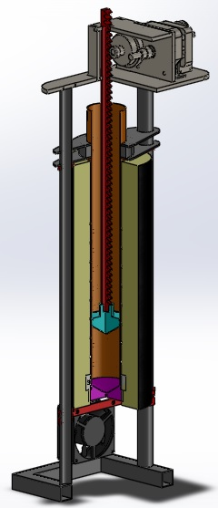

Figure 2. CAD Model of Final Design

**Design Concept Ideation and Selection**

The chosen design must be able to achieve all the main goals. The product must be able to heat and melt the plastic pellets, build pressure needed to extrude the melt, have interchangeable dies for different filament diameters, and it all must be stable during the entire process. The morphological chart shown below in the Appendix as Table 3 shows many different concepts considered by the design team.

In order to mount an interchangeable die that can withstand the pressures created during the extrusion process, three different designs were considered. A threaded die was first considered, but ultimately abandoned due to the difficulty involved with threading a diameter of 2.5” thin wall tubing. A die with an integrated clamping mechanism to grip the barrel was considered but abandoned for use in the prototype due to the added difficulty in machining. This design would be more desirable for a final product however due to the decrease in the number of parts and ease of assembly. The design ultimately chosen for attaching the die to the barrel was a shaft collar due to the simplicity in machining as well as the ability to use off the shelf parts if desired.

Many different design concepts were considered for building the necessary pressure. The top three designs are shown in Table 3. The simplest method considered was to use weights to add pressure to the melt, but this idea wasn’t chosen due to the amount of weight needed. To reach a pressure of 50 psi, about 250 lb. of weight would have to be applied to the piston, causing it to be much more difficult to stabilize the device. Another design considered was a motorized threaded gear and rod. As the threaded gear turned it would raise or lower the piston. This design was not chosen because of the difficulty in machining and mounting the threaded gear. The chosen design uses a rack gear as the shaft and a motorized pinion gear is used to raise and lower it. This design requires little machining and mostly uses off the shelf parts, but may require a simple transmission to get the desired pressure.

In order to hold the extruder assembly upright, a few different mounting methods were considered. A tripod type stand was initially thought up, but was quickly disregarded due to the difficulty in fabrication and in making sure the assembly is held vertical. The next method considered was much easier to machine and fabricate. It involves mounting the assembly to an “L” shaped panel with braces to support the weight. Another option considered was to just mount the assembly to the wall but was not chosen since it reduces the places were the user can place the product compared to if the device is free standing as well as the possible danger of mounting the heated device directly to the wall.

The barrel can be heated in many different ways. During the prototyping stage, external heat sources were used, but this idea was not chosen due to the inefficient and uneven heating and less user friendly operation. NiChrome wire, the type of heating wires common in most toasters, was strongly considered, but abandoned after researching heat cable. Heat cable is commonly used to keep pipes from freezing in the winter, but is still able to reach the desired temperatures and is not very expensive or complicated to install and readily connect with common PID controllers.

**Preliminary Concept Selection and Justification**

The chosen design must be able to heat and melt plastic pellets, build pressure required to extrude the melted plastic, have an interchangeable die for different filament diameters, and must be stable during the extrusion process. A shaft collar was chosen over a threaded die and an integrated clamp due to ease of fabrication. However, a groove was machined into the die in order to be captured by a lip in the die. This would keep the die from slipping out of the shaft collar during operation. A rack and pinion was chosen over the threaded gear and rod, and weights as the design to build pressure and extrude the plastic. It was determined that a significant amount of force would be required to extrude the plastic through the die by testing it with the weights first. The system required over 70 lb. of force to extrude filament at a slow rate, but much higher extrusion rates were desired to improve over our competitors designs. The weights were excluded as an option because it would require a significant amount of weights to provide the pressure necessary. About 250 lb. were necessary to reach a pressure of 50 psi inside the heating chamber. The threaded gear and rod design was eliminated due to the difficulty of capturing the gear and possible binding. This left the rack and pinion design which would allow for a motor to produce a significant amount of torque and low speeds. This design would also allow the team to control the extrusion speed. Finally, heat cable was chosen over the NiChrome wire and heat guns due to uniform heating and temperature control. The tube will be heavily insulated due to the high heat output of the heat cable, and in order to minimize heat loss. Figure 2 below shows a CAD assembly of all the selected design concepts. The size of the tube was chosen so the barrel could hold 1 kg. of pellets to match the sizes commercially available. The 2.5” diameter tube was chosen as a good balance. A smaller diameter required the tube to be taller to still accommodate 1kg of pellets, but would make heating the center easier while increasing the pressure induced with the same amount of downward force.

**Market Research**

The target market for our product remained individual 3D printer owners as well as small companies, universities, and paid-access workshop spaces. While this target group may not be very large, there is considerable interest in a product that produces usable plastic filament from virgin resin pellets or with recycled plastic parts such as old or failed 3D prints. Our initial survey released simultaneously across several online 3D printing forums and discussion groups indicated an interest in a fully automated machine priced below $300, as shown in figure 3 below.

Figure 3. Price vs. Prospective Buyers

Considerable interest was focused toward the current most common solution, devices capable of continuously being fed plastic pellets that are driven forward by an auger into a heated section. As mentioned earlier this design has been ruled out due to the cost and complexity of producing high-quality augers; also of note are the production inconsistencies and lower overall filament quality brought about by using makeshift augers.

Along with the first survey a phone interview was conducted with DuPont, one of the national leaders in plastic extrusions, which also provided useful information. We were informed of the complex screw profiles required to properly degas and pressurize plastics, as well as the diversity needed for plastics of different viscosities, such as ABS and PLA. This led us to the decision of a vertical piston model.

A second follow-up survey was released to the same online groups with more focused questions regarding our chosen design, with the results as follows:

* Pricing interest remained static with an optimum price point between $200 and $300
* There is some interest in a machine capable of producing a single kilogram of filament in less than eight hours compared to the current standard of twenty four hours
* Over 90% of respondents want to be able to make a variety of reel sizes leading up to one kilogram
* Over 90% of respondents want to have the machine run either entirely or mostly automatically

The desire for a faster production rate points toward a user need for a faster machine than currently exists on the market; our design is capable of those speeds or better when comparing its method of operation to existing models. The ability to extrude smaller amounts of plastic as well as larger ones can is simply a matter of measuring out smaller quantities of plastic with no changes to the overall design. Automatic operation - involving automatic piston actuation to a set internal pressure and temperature control - was a successfully achieved goal of the device, with only manual initiation and termination of the individual processes. These satisfy our target market's demands, indicating it will be a popular device upon its release.

**Industrial Design**

A preliminary logo to represent the product has been made as seen in Figure 4. This logo consists of a simplified, aesthetically pleasing representation of the product. However, further branding such as slogans have not been pursued. Aesthetic appeal is not one of the main goals for this product. The intent is to provide a highly functional machine for a hobbyist at as low a cost as possible. The device prioritizes functionality over fashion. Measures have been taken, however, to ensure the device takes up a small footprint on ones’ workshop, approximately 1ft.x2ft. The small footprint of the vertical piston design is ideal for saving space. Ergonomics of use is another design challenge that was faced. Ergonomically, attention is being taken to limit the height of the object so the user does not have to reach high. The chosen 2.5” diameter of the piston limits the stroke of the piston for a full 1-kg load to around 13.5 in, thus minimizing the full height required for the machine to less than 3 feet. This allows the device to be either operated on the ground or elevated on a table. The final task in the design process was concealing the insulation around the piston. The final decision was a sleek aluminum tube with a 6 in. diameter. This allowed the insulation to be fully expanded and efficiently keep the piston at 200 C. It also dissipated heat rapidly enough that it could be touched without fear of burning or injury.



Figure 4. Preliminary Logo

**Social, Environmental and Sustainability Considerations**

The demographic that our plastic filament extruder is geared toward is very limited. It is certain that there is a demand for this, due to the $40,000 prize offered to whoever could successfully complete the task of producing cheap and reliable 3D filament. The prize was recently won, which has turned our project into creating a competitive device instead of the first of its kind. The current auger driven model takes nearly 5 hours to produce 1 kilogram of filament, whereas our piston driven model will ideally produce the same result in less 10% of the time. This could greatly impact the 3D printing industry by significantly reducing the high cost of filament, and making it simple to manufacture and sell filament without the need of thousands of dollars of machinery. This could potentially put current filament vendors out of business, or cause them to lower their prices to a competitive level. Environmental effects would be minimal to non-existing from the plastic extruder. However, the extruder will allow for users to grind up old pieces of plastic from prior 3D prints or other scrap ABS plastic pieces. In this way, the extruder system creates a new way for people to recycle plastic.

**Risk Assessment**

When producing 3D printer filament, a large amount of heat is required in order to fully melt ABS plastic to its glass transition state. Using a PID controller and heating wire wrapped around the aluminum barrel allows heat to be evenly distributed to the plastic. The heat, however, also travels though the highly conductive metal causing the majority of the device to be heated to a temperature high enough to be harmful if touched. To counteract this risk, an outer case of stainless steel furnace ducting was added outside of the insulation around the barrel. This outer layer never gets hot enough to burn in normal operation. Now, users can only be burnt by reaching around the bottom of the case to the die or over the top to the top of the barrel. Neither of these can be better protected without sacrificing functionality of the product. In preliminary trials, the insulation used showed burn marks where it came in direct contact with the heating wire. For the final product, several types of insulation were tested and a high temperature glass insulation was chosen. Even if the heating wire overheated, this material may have some discoloration but will not burn.

The extruded plastic is cooled by a cooling fan to a temperature that will not burn skin within inches of being extruded from the die. The user will not be burnt by the extruded plastic unless they reach up under the case to get burnt by the extruded plastic.

The AC gearmotor used to drive the extruder piston has built-in overload protection, and is UL tested and approved for use in open environments. There is negligible risk of the motor overheating or starting a fire.

**Detailed Technical Analyses and Design Performance Predictions**

Force Analysis: The initial goal for this project was toextrude filament at a speed of 10 in/min. Furthermore, the plastic in the barrel needed to be pressurized in order to extrude high quality plastic consistently. Initial trials used weights to drive the piston. Weights up to 85 lb were tested, with both filament quality and extrusion rate increasing with each increase in weight. However, the weight was not sufficient to accomplish the project goals. The 85 lb filament only extruded filament at a speed of roughly 5 in/min. The area of the piston is 4.53 in2, so 85 lbf results in a barrel pressure of 19 psi. In order to increase the pressure in the barrel, an electric drive system was created. This system uses an AC gearmotor that spins at 1 RPM with a torque of 50 in-lb. To adapt this motor to the extrusion application, the motor had to be further geared down. A transmission was created to gear down the motor by a factor of 3.2. This was accomplished by attaching a 15 tooth gear to the motor output shaft, which turned a 50 tooth gear that was welded to another 15 tooth gear. This second 15 tooth gear propels a linear gear rack that is connected to the piston. Table **X** shows the speed and torque at each stage of the transmission. The transmission results in a linear force of 213 lbf, and a linear piston speed of 0.736 in/min. This results in a barrel pressure of 47 psi. Assuming the motor does not slow down as it is loaded, this also results in a filament feed of 35 in/min. This motor was shown to provide adequate pressure to make filament quality similar to commercially sourced filament. The motor is cycled on and off to maintain pressure in the barrel with a feed rate of 24 in/min or higher.

The transmission case needed to be as light as possible in order to keep the center of gravity of the machine low and ensure a stable machine. Solidworks CosomosWorks Finite Element Analysis was utilized to evaluate different transmission case designs, as well as ensure safety. The final design for the transmission case is ¼” Aluminum 6061 plate. Figure **X** in the Appendix shows that stresses in this plate are below the yield point of the Aluminum, and deflection of the transmission is at an acceptably low value of less than 0.1 mm vertical deflection.

Table 1. Transmission Gear Information

|  |  |  |  |
| --- | --- | --- | --- |
|  | 15 Tooth (Motor Gear) | 50 Tooth | 15 Tooth (Rack Gear) |
| Pitch Dia | 0.75 | 2.4 | 0.75 |
| RPM | 1 | 0.3125 | 0.3125 |
| Linear Speed |  |  | **0.736** |
| Torque (in-lb) | 50 | 160 | 160 |
| Linear Force |  |  | **213.3** |

Thermal Analysis: Based on calculations performed assuming the wall and air was held at a constant 110°C, a lumped capacitance analysis was performed for a spherical ABS plastic pellet whose thermal conductivity is 0.23 W/mK with a diameter of 3mm starting at 20°C and ending at 105°C with a convection coefficient *h* of 25 W/m2K. From the Biot equation,

$$Bi=\frac{h(D/6)}{k}$$

a result of *Bi* = 0.0543 was obtained which is less than 0.1, confirming lumped capacitance is valid for this scenario. Following this, using the equations

$$τ=\frac{ρc_{p}D}{6h}$$

$$t=τ\ln\left(\frac{T_{i}-T_{∞}}{T-T_{∞}}\right)=42.89 seconds$$

the result for the pellet's time constant and time to reach the desired temperature were identified, respectively. This gave us a time of 42.89 seconds to reach the glass transition temperature of 105°C. From there, approximately twelve and a half minutes are required to heat the plastic pellets to a roughly uniform temperature through the tube’s radius assuming the device is 100% preheated. From our initial experiments, this was a fairly accurate estimate of the thermal characteristics of the plastic. It should be noted that pre-heating time takes an approximately equal amount of time, so if the plastic pellets are introduced to the device while it is cold it will take roughly twenty to twenty five minutes before it is fully melted depending on the quantity of plastic present.  
 Also with regards to thermal characteristics, we were able to identify a more pressing concern through testing: the time it takes to get the apparatus to an even temperature. While the tube itself heated very quickly, the piston head and die took much longer to heat. Of particular note was the die, which is both large and highly conductive. Both of these worked against us by slowing the rate at which the die reaches a suitable operating temperature, which was solved by a reduced die mass, relocating some of the heating wire directly to the surface of the die, and an increased use of insulating materials. With these changes, the die reached operating temperatures in a vastly reduced timeframe.

After executing several test runs of the device it was decided that additional cooling would be required to ensure higher quality filament was produced by solidifying it before it drew itself into an unusable super-thin strand. With the equation

$$t=\frac{\left(ρc_{p}({D_{filament}}/2)\right)}{T_{filament}}\ln\left(\frac{T_{filament}-T_{∞}}{T_{glass}-T_{∞}}\right)$$

We were able to determine how quickly the filament was cooling now: 6.35 seconds to 105°C from 220°C, and from there determine a more optimal cooling rate. We were able to identify that fans with a flow rate of approximately 60 cubic feet per minute would be suitable to drop the cooling rate to at least half that, and a suitable 120mm AC fan was integrated into the design as a result.

**Manufacturing**

The main plan with this device is to supply the design and bill of materials as an open source design. This would mean it would be up to the user to build and fabricate the design. However, if this were to be produced commercially with large volumes, it would be best to change the methods used to construct the device. The piston and die could be cast with just a small amount of post machining. In order to speed up the machining process, CNC mill fixtures could be used to position multiple parts at one time to reduce setup times and costs. The aluminum tube used as a heating chamber, the tubes for the stand, the rack gear, and the shafts for the transmission would be ordered in bulk to save costs. In order to save time on cutting these parts to length, a horizontal band saw with an automated feed would be used. A weld fixture should be developed in order to speed up and improve the tolerances for the stand. The aluminum parts used to mount the motor and transmission would be replaced with steel to reduce costs. These parts would be machined using a waterjet, cutting from a large piece of material so that multiple pieces could be cut out at one time.

**Budget**

The budget limit for our filament extrusion prototype was $500. After a market research survey was conducted, the new budget limit for one machine, assuming mass production, was set to $250. The majority of our parts were purchased from McMaster Carr. These parts came in standard sizes which were usually much larger than what was required for our prototype. All parts such as tubing, structural support beams, and the rack came with enough material to make 2 prototypes. The only parts that would not cover 2 or more machines were the gears and motor for the drive train and the PID controller. If all these parts were purchased in bulk, the material prices could be reduced to approximately $200 per prototype which is significantly less expensive than our final expenses of $435.52 which can be seen in in Table 1.

Table 2. Expense Reports



**Commercialization**

Based on the future career goals of the team, it was decided that the device's design and documentation in its entirety would be released under an Open Source license to be freely downloaded at the end of the semester. Specifically, a Creative Commons Attribution 3.0 Unported [International] license was selected for the device. This will permit those who desire to produce copies or use our designs as a starting point on new versions to freely work with what we have produced, with the stipulation that we - the creators of the device - and the Georgia Tech Capstone Design program are attributed in every future copy or successive iteration of the design.

In many respects, this choice is ideal due to the nature of our device; while fully functional, it is still a first-generation prototype. Attempting to sell it as-is versus opening it to a vast community of developers would not be an ideal scenario at the present time. Choosing to release it in this manner will ensure that the device continues to gain additional features we did not have time or funding to implement. Additionally, this design and every variation that stems from it will serve as a standing record of this team's work throughout this semester and of the Capstone Design program at Georgia Tech.

**Conclusion and Future Work**

Using market research and several design tools, the team successfully developed a plan for the project. The team held a phone conference with a representative of DuPont in order to obtain expert advice on different extrusion techniques. This allowed the team to better understand the pros and cons of the different techniques. Using this information, the team was able to make a more informed decision on the direction of the project. The Gantt chart shown by Figure 5 below was used to create a schedule of all the project deadlines so the team could plan accordingly in order to complete each task in a timely manner.

Figure 5. Project Gantt Chart

The team continued to research extruding and heating techniques as well as researching related patents, which have resulted in the final design of the device. The team designed a 3D model of the product in order to determine every part that needed to be included. The team then performed a heat transfer analysis of the device in order to determine the best arrangement of heating elements and insulating material to incorporate into the design. The team also conducted an analysis of the different manufacturing processes that will be used to build this product and used those analyses to produce the current components incorporated into the first prototype. Upon successfully completing these tasks the team began to prototype and test the product to further refine the design and improve its functional characteristics. Testing and slight design alterations continued until a fully operational prototype was obtained. The team successfully produced a prototype that could extrude 1 kilogram of filament in approximately 30 minutes. This extrusion time far exceeds the 8 hour extrusion time of competitor designs. Using a piston method rather than an auger, allowed the team to create a significant amount of pressure which allowed for extrusion speeds 16 times that of other products.

In order for this product to be marketable, it must be more automated and have a reeling system. Therefore the next steps for the team are to design and manufacture a reeling system that can wind the filament on to a reel as it is being extruded, and to also develop a way to make the product more automated and user friendly. At this point if the user wants to load a new batch of pellets into the system, he/she must disconnect a gear and pull the piston up by hand. To assess this problem, the team would have to develop a way to easily reverse the direction of the motor. After completing these two tasks, the team would then focus on making the product more aesthetically appealing to the user. Once this is all complete, the team could successfully market and sell the product to individuals and small businesses.

**References and Citations**

[1] http://www.filabot.com

[2] http://www.thingiverse.com/thing:34653

[3] http://www.kickstarter.com/projects/rocknail/filabot-plastic-filament-maker

[4] http://thingiverse-production.s3.amazonaws.com/assets/69/a2/87/63/17/LYMAN_FILAMENT_EXTRUDER_II_MANUAL.pdf

[5]http://www.google.com/patents/US4067554?printsec=abstract&dq=paul+troester+plastic#v=onepage&q=paul%20troester%20plastic&f=false

[6]http://www.google.com/patents/EP0887116A2?cl=en&dq=dohle&hl=en&sa=X&ei=EcoRUaL0D4Tu9ASGh4HwCA&ved=0CEQQ6AEwBA

[7] http://www.marplex.com.au/technical/A%20guide%20to%20ABS%20Pellet%20Drying.pdf

[8] http://www.distrupol.com/images/Toyolac(TM)_Injection_Moulding_Guide.pdf

[9] http://www.dynalabcorp.com/technical_info_abs.asp

[10] http://www.ita.mx/files/gui-ingles-tecnico-nov-2012/ing-mecanica-2-11-2012-1.pdf

**Appendix**

**Drawing and Fabrication Package**

The vertical piston was chosen to be the best design for filament extrusion. Manufacturing of a prototype consisted of ordering raw materials and machining to specified dimensions using a lathe and mill. This was found to be the most cost effective way for an initial prototype and orders in small amounts. However, if this product were to be mass produced, many of the parts may be able to be cast and post machined to specification. This would probably be the most cost effective way to manufacture the vertical piston for mass production. Also some parts, like the shaft collar, were machined due to the high cost of buying a large diameter shaft collar. In the case of a large scale production, it may be more cost effective to buy commercial parts in bulk. This would allow for the cost per assembly in mass production to be significantly reduced. A bill of materials with an associated CAD model is shown by Table 4 below and Figure 6.

Table 4. Vertical Piston Bill of Materials

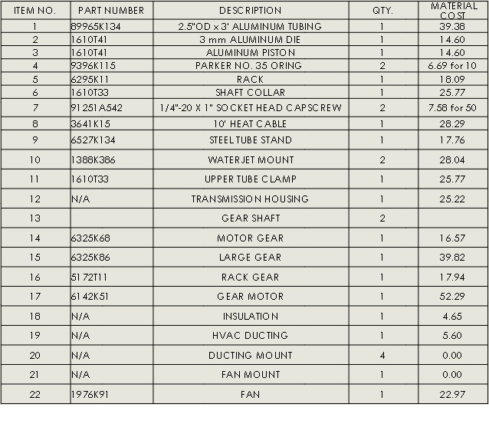

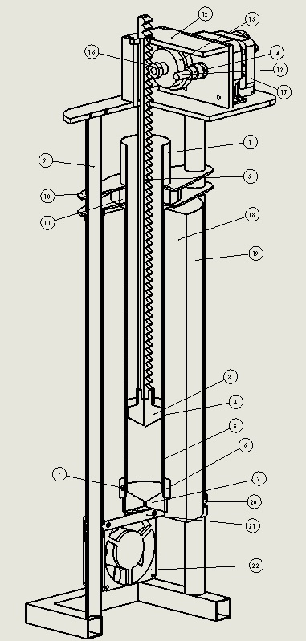

Figure 6. Vertical Piston Exploded View

Table 3. Morphological Chart

|  |  |  |  |
| --- | --- | --- | --- |
| **Function** | **Concepts** | | |
| **Mount Interchangeable Die to Barrel** | Threaded | C:\Users\Jason.PHYLIS-LAPTOP\Desktop\Senior Design\Vertical Piston Concept\Shaft Collar.JPG  Shaft Collar | C:\Users\Jason.PHYLIS-LAPTOP\Desktop\Senior Design\Vertical Piston Concept\Integrated Clamp.JPG  Integrated Clamp |
| **Build Pressure** | C:\Users\Jason.PHYLIS-LAPTOP\Desktop\Senior Design\Vertical Piston Concept\Weights.JPG  Weights | C:\Users\Jason.PHYLIS-LAPTOP\Desktop\Senior Design\Vertical Piston Concept\Threaded Gear and Rod.JPG  Threaded Gear and Rod | C:\Users\Jason.PHYLIS-LAPTOP\Desktop\Senior Design\Vertical Piston Concept\Rack and Pinion.JPG  Rack and Pinion |
| **Mount Assembly** | C:\Users\Jason.PHYLIS-LAPTOP\Desktop\Senior Design\Vertical Piston Concept\Support.JPG  Tripod like stand | C:\Users\Jason.PHYLIS-LAPTOP\Desktop\Senior Design\Vertical Piston Concept\Support 2.JPG  Panel |  |
| **Heat Barrel** | http://img0047.popscreencdn.com/123987148_nichrome-wire-36-gauge-250-feet-ebay.jpg  NiChrome Wire | http://image.made-in-china.com/2f0j00DeZaiRgPsUpn/Constant-Wattage-Heating-Cable.jpg  Heat Cable | http://www.harborfreight.com/media/catalog/product/cache/1/image/9df78eab33525d08d6e5fb8d27136e95/i/m/image_11971.jpg  Heating Gun/External Source |

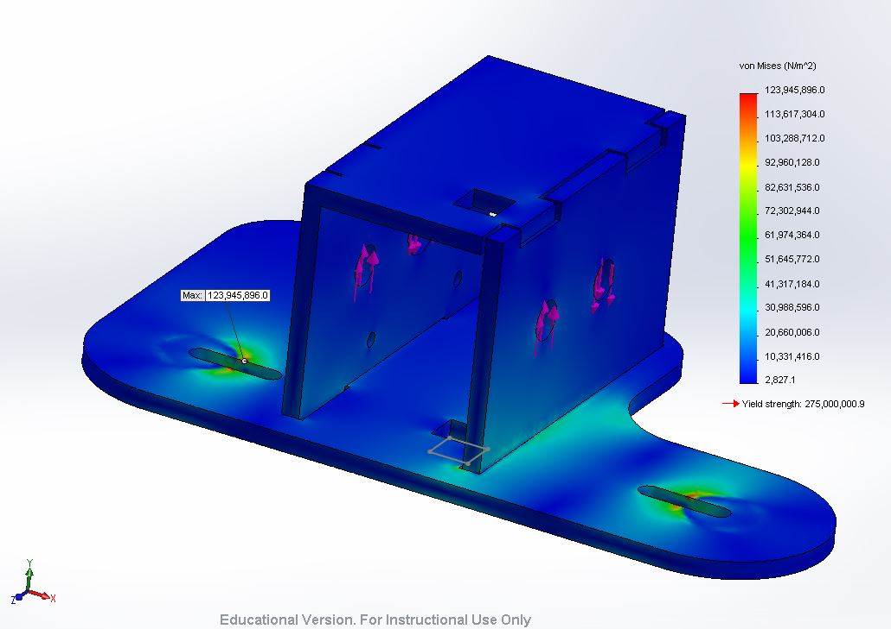

**Figure 7. Solidworks CosmosWorks FEA of transmission case**